哈尔滨工业大学计算学部
实验报告

课程名称：数据结构与算法
课程类型：专业核心基础课（必修）
实验项目：树形结构及应用
实验题目：哈夫曼编码与译码方法
实验日期：2023/10/11

班级：2203101
学号：2022113573
姓名：张宇杰

设计成绩 | 报告成绩 | 指导老师
 |  | 张岩

一、实验目的
哈夫曼编码是一种以哈夫曼树（最优二叉树，带权路径长度最小的二叉树）
为基础变长编码方法。其基本思想是：将使用次数多的字符转换成长度较短的编
码，而使用次数少的采用较长的编码，并且保持编码的唯一可解性。在计算机信
息处理中，经常应用于数据压缩。是一种一致性编码法（又称"熵编码法"），用
于数据的无损压缩。本实验要求实现一个完整的哈夫曼编码与译码系统。

二、实验要求及实验环境
实验要求：
1. 从文件中读入任意一篇英文文本文件，分别统计英文文本文件中各字符（包
括标点符号和空格）的使用频率；
2. 根据已统计的字符使用频率构造哈夫曼编码树，并给出每个字符的哈夫曼编
码（字符集的哈夫曼编码表）；
3. 将文本文件利用哈夫曼树进行编码，存储成压缩文件（哈夫曼编码文件）；
4. 将哈夫曼编码文件译码为文本文件，并与原文件进行比较。
5. 计算你的哈夫曼编码文件的平均编码长度和压缩率，并与实验结果比较验证；
6. 选做：上述 1-5 的编码和译码是基于字符的压缩，考虑基于单词的压缩，完
成上述工作，讨论并比较压缩效果。
7. 选做：上述 1-5 的编码是二进制的编码，可以采用 K 叉的哈夫曼树完成上述
工作，实现“K 进制”的编码和译码，并与二进制的编码和译码进行比较。
8. 选做：利用堆结构，优化哈夫曼编码算法。

实验环境：
Windows 11, g++, gdb

三、设计思想（本程序中的用到的所有数据类型的定义，主程序的流程图及各程序模块之间的调用关系、核心算法的主要步骤）
1．逻辑设计
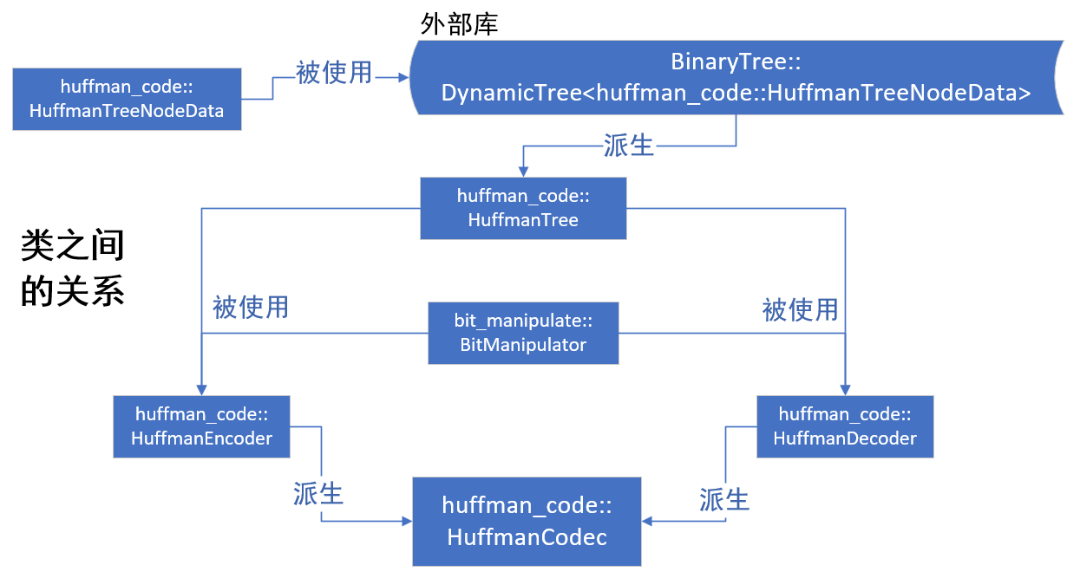
命名空间：bit_manipulate
- namespace bit_manipulate
自定义类 bit_manipulate::BitManipulator
- class BitManipulator
- {
- public:
- void write_bits(std::ostream& stream_dest, const std::string& bits_src);

- std::string read_bits(std::istream& stream_src);

- char byte_to_char(const std::string& bits_src, std::string::const_iterator& src_iter, int zero_supplement_len = 0);

- std::string char_to_byte(char char_src, int zero_supplement_len = 0);
- };

命名空间：huffman_code
- namespace huffman_code
自定义类 huffman_code::HuffmanTreeNodeData
- class HuffmanTreeNodeData
- {
- public:
- char ch;
- unsigned int weight;

- HuffmanTreeNodeData(): ch('\0'), weight(0){};

- HuffmanTreeNodeData(char _ch, unsigned int _weight): ch(_ch), weight(_weight){};

- friend std::ostream& operator<<(std::ostream& out, const huffman_code::HuffmanTreeNodeData& data);

- friend std::istream& operator>>(std::istream& in, huffman_code::HuffmanTreeNodeData& data);
- };
以下均使用别名
- // an alias
- using Node = BinaryTree::DynamicNode<HuffmanTreeNodeData>;
自定义类 huffman_code:: HuffmanTree
- class HuffmanTree: public BinaryTree::DynamicBinaryTree<HuffmanTreeNodeData>
- {
- public:
- void make_huffman_tree(std::map<char, int>& freq_map);

- class greater
- {
- public:
- inline bool operator()(Node* p1, Node* p2)
- {
- return p1->data.weight > p2->data.weight;
- }
- };
- };
自定义类 huffman_code:: HuffmanEncoder
- class HuffmanEncoder
- {
- private:
- HuffmanTree tree;

- // a map from char to the char's frequency
- std::map<char, int> freq_map;

- // a map from char to the char's huffman-code
- std::map<char, std::string> code_map;

- // the vector relative frequency
- std::vector<double> r_freq_vec;

- // create code map by recursion
- void _rec_make_code_map(Node* p_node, std::string code);

- // calculate the relative frequency
- void _calc_freq();

- public:
- // calculate the frequency
- void get_freq(std::istream& stream_src);

- // make code map by huffman tree
- void make_code_map();

- // encode the source stream to binary string
- void encode_to_str(std::istream& stream_src, std::string& bits_dest);

- // encode the source stream to binary string, and output to a stream destination
- void encode_to_stream(std::istream& stream_src, std::ostream& code_dest);

- void show_freq_map(std::ostream& out);

- void show_code_map(std::ostream& out);

- double avg_code_len();
- };
自定义类 huffman_code:: HuffmanDecoder
- class HuffmanDecoder
- {
- private:
- HuffmanTree tree;

- void create_tree(std::istream& in, char placeholder);

- void _create(std::istream& in, Node*& p, char placeholder);

- public:
- void decode_to_stream(std::istream& huffman_stream_src, std::ostream& char_stream_dest);

- inline HuffmanTree& get_tree()
- {
- return tree;
- }
- };
自定义类 huffman_code:: HuffmanCodec
- class HuffmanCodec: private HuffmanEncoder, private HuffmanDecoder
- {
- public:
- void encode(std::string input_filename, std::string output_huffman_filename = "");

- void decode(std::string input_huffman_filename, std::string output_filename = "");

- void show_freq_map(std::ostream& out)
- {
- HuffmanEncoder::show_freq_map(out);
- }

- void show_code_map(std::ostream& out)
- {
- HuffmanEncoder::show_code_map(out);
- }

- double avg_code_len()
- {
- return HuffmanEncoder::avg_code_len();
- }
- };
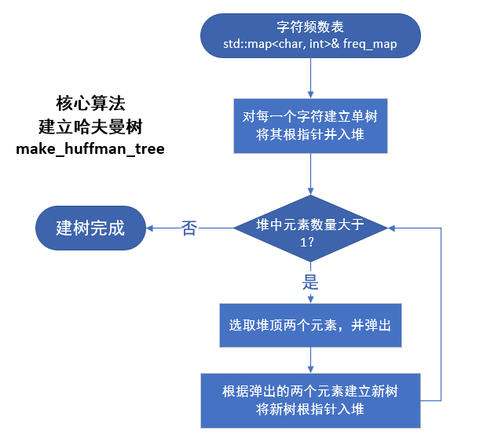
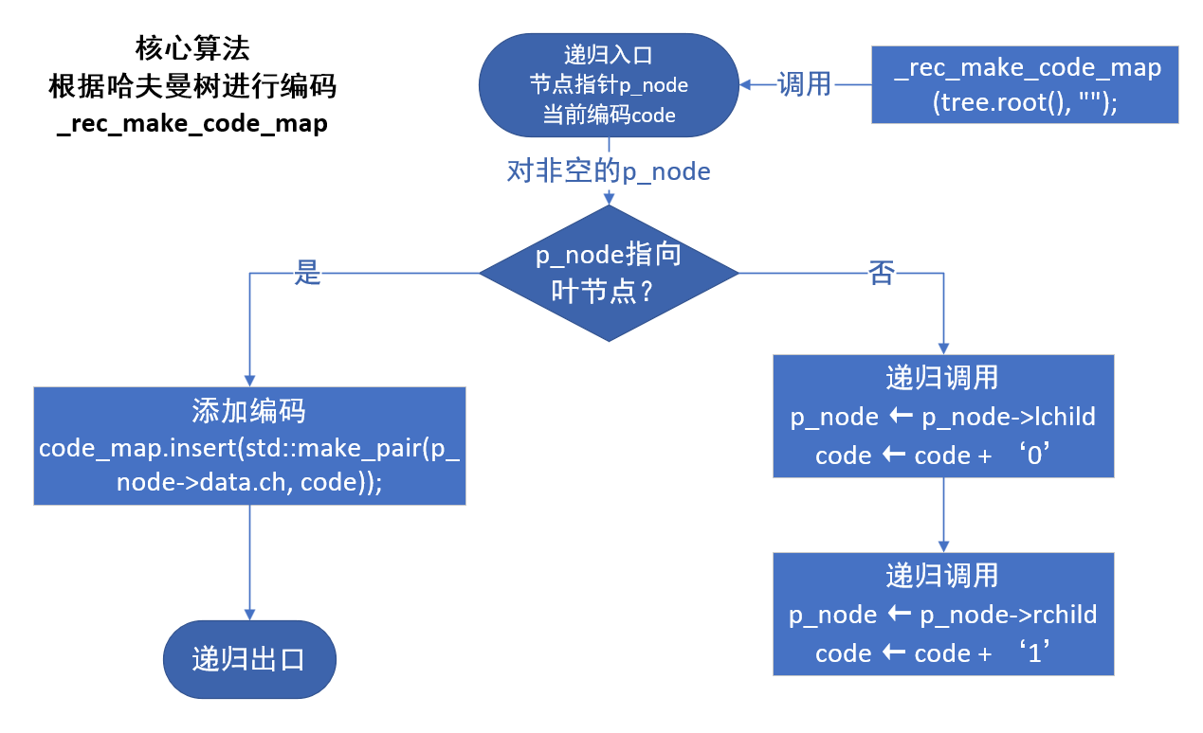
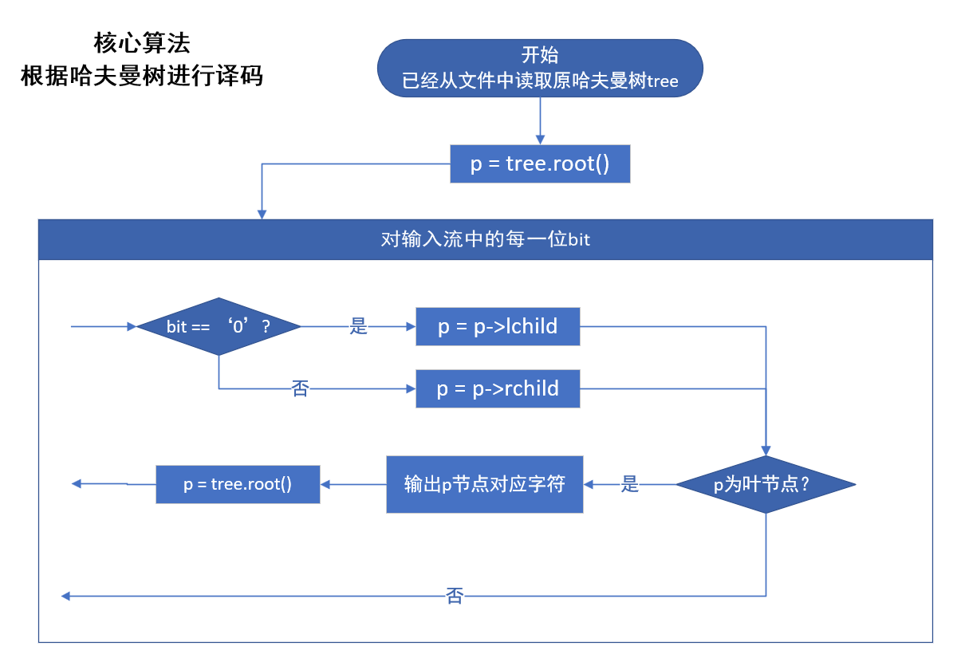
2．物理设计（即存储结构设计）
使用STL容器vector, map, priority_queue
使用自定义类BinaryTree::DynamicTree
四、测试结果（包括测试数据、结果数据及结果的简单分析和结论，可以用截图得形式贴入此报告）
一、对字符进行统计
运行程序：
- #include <iostream>
- #include "./header/HuffmanCodec.hpp"

- using namespace std;
- using namespace huffman_code;

- int main(int argc, const char *argv[])
- {
- HuffmanCodec codec;

- codec.encode("./texts/Youth.txt");

- codec.show_freq_map(cout);

- return 0;
- }
输出结果：
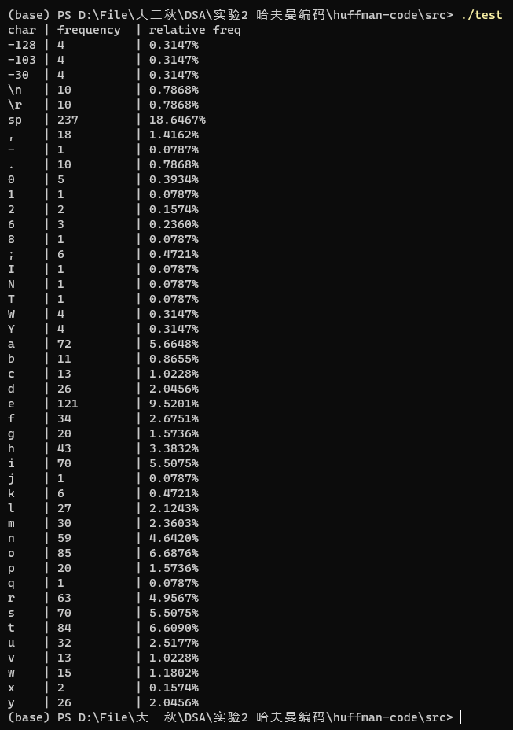
结论：输出无误

二、根据已统计的字符使用频率构造哈夫曼编码树，并给出每个字符的哈夫曼编
码
运行程序：
- #include <iostream>
- #include "./header/HuffmanCodec.hpp"

- using namespace std;
- using namespace huffman_code;

- int main(int argc, const char *argv[])
- {
- HuffmanCodec codec;

- codec.encode("./texts/Youth.txt");

- codec.show_code_map(cout);

- return 0;
- }
输出结果：
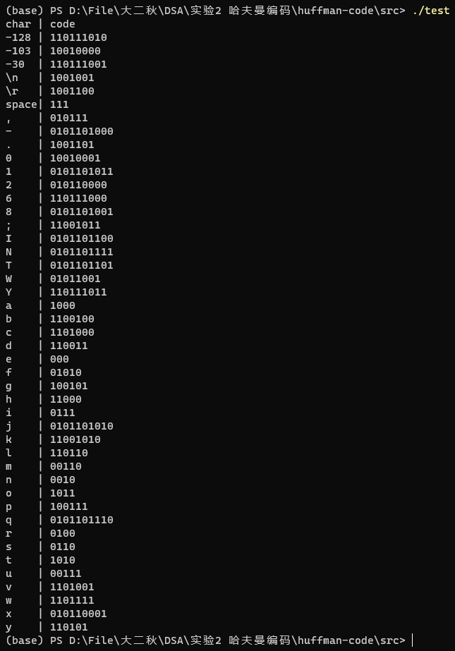
结论：输出无误

三、将文本文件利用哈夫曼树进行编码，存储成压缩文件（哈夫曼编码文件）
运行程序：
- #include <iostream>
- #include "./header/HuffmanCodec.hpp"

- using namespace std;
- using namespace huffman_code;

- int main(int argc, const char *argv[])
- {
- HuffmanCodec codec;

- codec.encode("./texts/Youth.txt");

- return 0;
- }
输出结果：
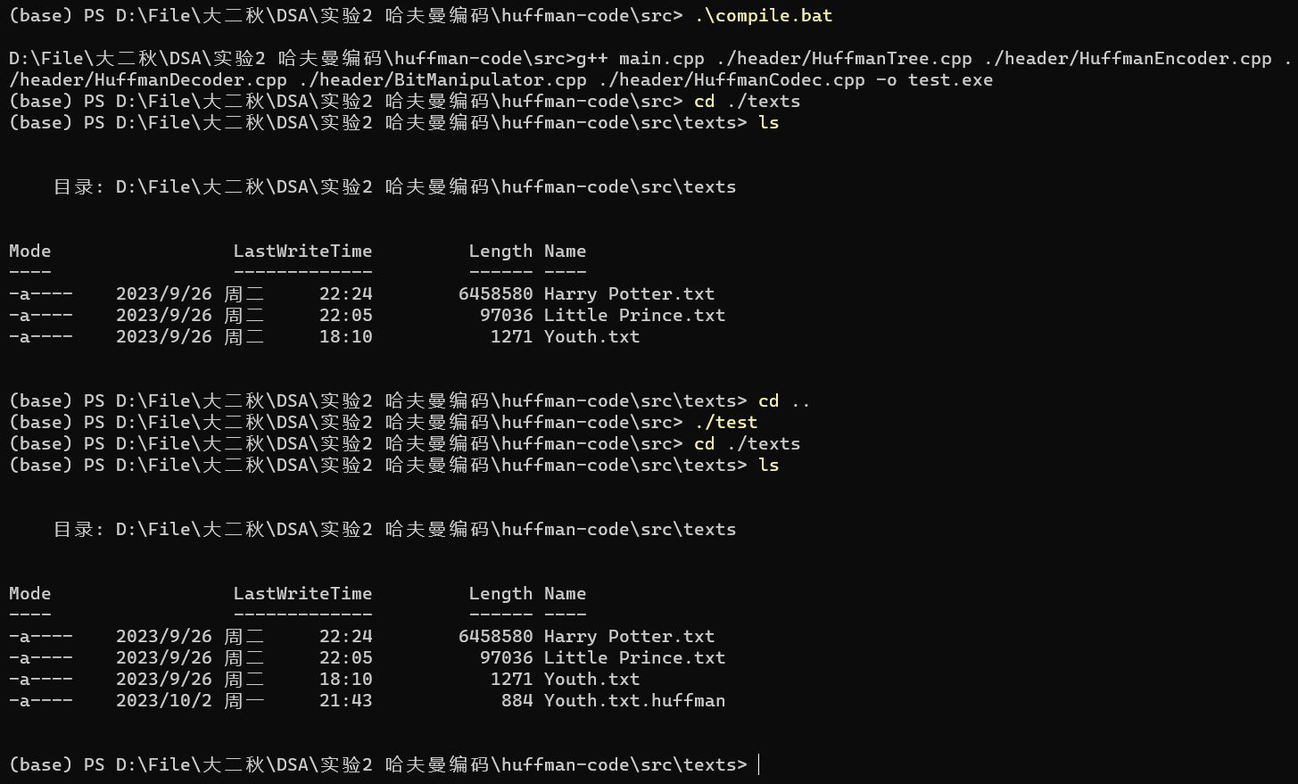
成功输出Youth.txt.huffman文件，大小为884字节
原文件Youth.txt大小为1271字节

四、将哈夫曼编码文件译码为文本文件，并与原文件进行比较
运行程序：
- #include <iostream>
- #include "./header/HuffmanCodec.hpp"

- using namespace std;
- using namespace huffman_code;

- int main(int argc, const char *argv[])
- {
- HuffmanCodec codec;

- codec.decode("./texts/Youth.txt.huffman", "./texts/out.txt");

- return 0;
- }
输出结果：
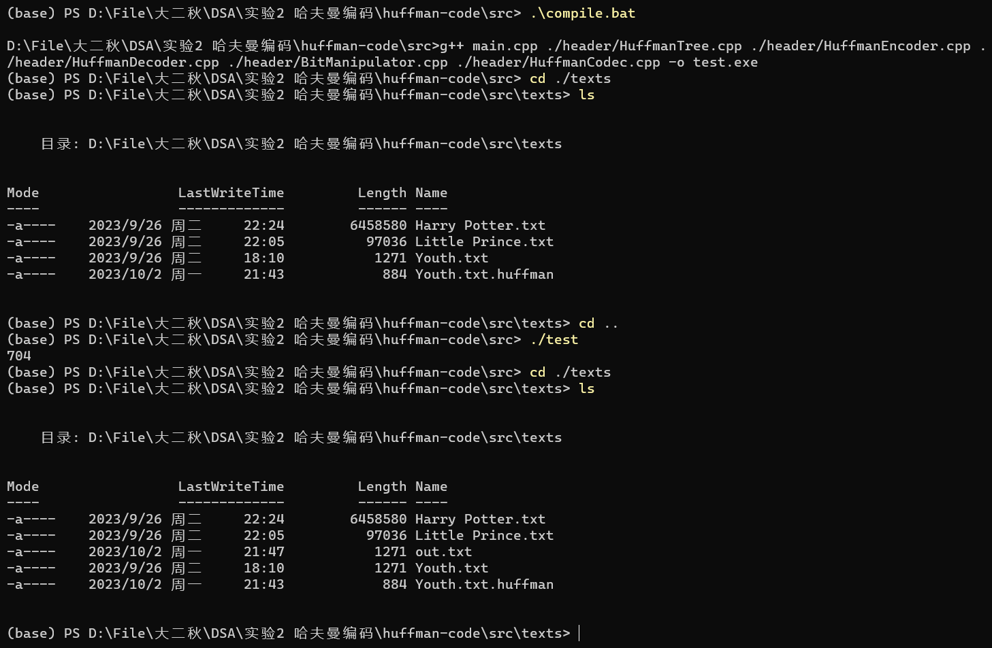
成功生成输出文件out.txt
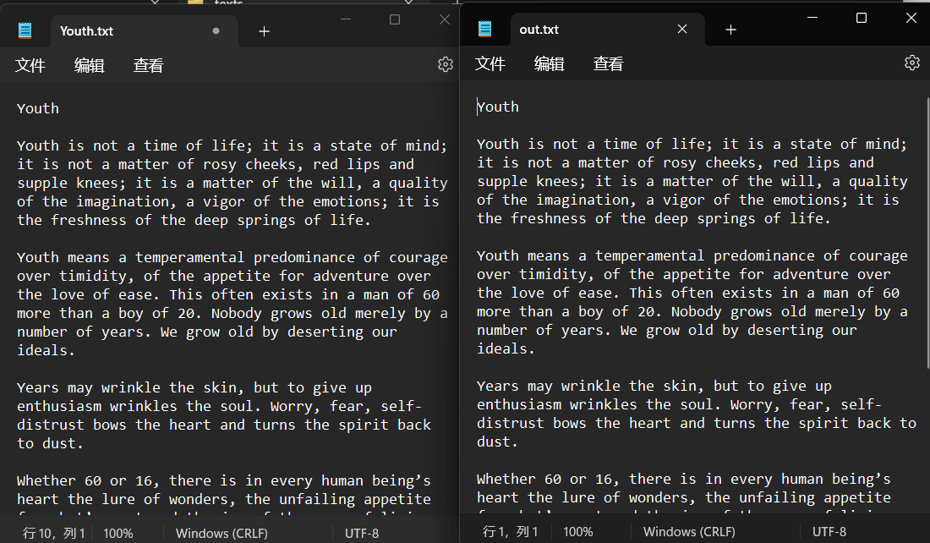
其内容与原文件一致

五、计算你的哈夫曼编码文件的平均编码长度和压缩率，并与实验结果比较验证
运行程序：
- #include <iostream>
- #include "./header/HuffmanCodec.hpp"

- using namespace std;
- using namespace huffman_code;

- int main(int argc, const char *argv[])
- {
- HuffmanCodec codec;

- codec.encode(argv[1]);

- cout << codec.avg_code_len() << endl;

- return 0;
- }
输出结果：
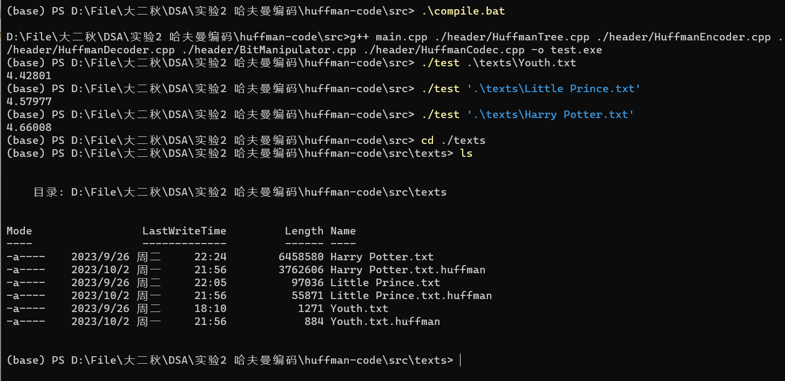
结果汇总：
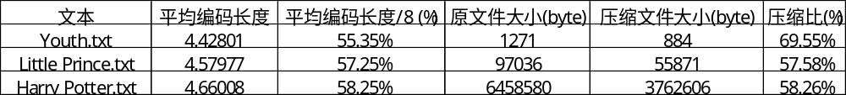
随着文件大小的上升，“压缩比”逐渐趋同于“平均编码长度比8值”
这是因为，即使文件大小有了显著的增加，存储哈夫曼树所需的空间也几乎不会有太大变化
五、经验体会与不足
经验体会：
深刻地理解了哈夫曼编码的原理，成功实现了压缩文件的功能
不足：
代码结构有待改善

六、附录：源代码（带注释）
BitManipulator.hpp
- #ifndef _BIT_MANIPULATOR_HPP_
- #define _BIT_MANIPULATOR_HPP_

- #include <iostream>

- namespace bit_manipulate
- {
- class BitManipulator
- {
- public:
- /**
- * @brief write a binary string to the stream
- * supplement some zeros in front of the binary string
- * if the string len is not divisible by 8
- * write the length of the supplement zero before writing the binary string
- * @param stream_dest the stream destination
- * @param bits_src the binary string source
- */
- void write_bits(std::ostream& stream_dest, const std::string& bits_src);

- /**
- * @brief read binary string from the stream
- * the stream source must be written by "write_bits"
- * @param stream_src the stream source
- * @return the binary string
- */
- std::string read_bits(std::istream& stream_src);

- /**
- * @brief convert a binary string byte to a char
- * i.e. a binary string with the length of 8
- */
- char byte_to_char(const std::string& bits_src, std::string::const_iterator& src_iter, int zero_supplement_len = 0);

- /**
- * @brief convert a char to a binary string byte
- * i.e. a binary string with the length of 8
- */
- std::string char_to_byte(char char_src, int zero_supplement_len = 0);
- };
- }

- #endif
BitManipulator.cpp
- #include "./BitManipulator.hpp"

- /**
- * @brief write a binary string to the stream
- * supplement some zeros in front of the binary string
- * if the string len is not divisible by 8
- * write the length of the supplement zero before writing the binary string
- * @param stream_dest the stream destination
- * @param bits_src the binary string source
- */
- void bit_manipulate::BitManipulator::write_bits(std::ostream& stream_dest, const std::string& bits_src)
- {
- // calc and write the length of zeros to be supplemented
- int zero_supplement_len = 8 - bits_src.size() % 8;
- stream_dest << (char)zero_supplement_len;

- // write the binary string
- auto iter = bits_src.cbegin();
- while (iter != bits_src.cend())
- {
- stream_dest << byte_to_char(bits_src, iter, zero_supplement_len);

- // if the zeros have been supplemented
- if (zero_supplement_len > 0)
- // no need to supplement zeros
- zero_supplement_len = 0;
- }
- }

- /**
- * @brief read binary string from the stream
- * the stream source must be written by "write_bits"
- * @param stream_src the stream source
- * @return the binary string
- */
- std::string bit_manipulate::BitManipulator::read_bits(std::istream& stream_src)
- {
- // buffer for return value
- std::string ret;

- // get the zeros supplemented
- char zero_supplement_len = stream_src.get();

- char ch;
- /// int cnt = 0;
- while (ch = stream_src.get(), !stream_src.eof())
- {
- // append binary strings to the return value
- // byte by byte
- ret += char_to_byte(ch, (int)zero_supplement_len);

- if (zero_supplement_len > '\0')
- zero_supplement_len = '\0';

- /// cnt++;
- }
- /// std::cout << cnt << std::endl;

- return ret;
- // return std::move(ret);
- }

- /**
- * @brief convert a binary string byte to a char
- * i.e. a binary string with the length of 8
- */
- char bit_manipulate::BitManipulator::byte_to_char(const std::string& bits_src, std::string::const_iterator& src_iter, int zero_supplement_len)
- {
- char ret = 0;
- for (int i = 0; i < 8 - zero_supplement_len; ++i, ++src_iter)
- {
- ret <<= 1;
- if (*src_iter == '1')
- ret |= 1;
- }
- return ret;
- }

- /**
- * @brief convert a char to a binary string byte
- * i.e. a binary string with the length of 8
- */
- std::string bit_manipulate::BitManipulator::char_to_byte(char char_src, int zero_supplement_len)
- {
- std::string ret;
- for (int i = (1 << (7 - zero_supplement_len)); i > 0; i >>= 1)
- {
- if ((i & char_src) != 0)
- ret += '1';
- else
- ret += '0';
- }
- return std::move(ret);
- }
HuffmanTree.hpp
- #ifndef _HUFFMAN_TREE_HPP_
- #define _HUFFMAN_TREE_HPP_

- #include "./binary-tree/DynamicBinaryTree.hpp"
- #include <iostream>
- #include <map>

- namespace huffman_code
- {
- class HuffmanTreeNodeData
- {
- public:
- char ch;
- unsigned int weight;

- HuffmanTreeNodeData(): ch('\0'), weight(0){};

- HuffmanTreeNodeData(char _ch, unsigned int _weight): ch(_ch), weight(_weight){};

- friend std::ostream& operator<<(std::ostream& out, const huffman_code::HuffmanTreeNodeData& data);

- friend std::istream& operator>>(std::istream& in, huffman_code::HuffmanTreeNodeData& data);
- };

- // an alias
- using Node = BinaryTree::DynamicNode<HuffmanTreeNodeData>;

- class HuffmanTree: public BinaryTree::DynamicBinaryTree<HuffmanTreeNodeData>
- {
- public:
- void make_huffman_tree(std::map<char, int>& freq_map);

- // a compare functor, which compares the weight in HuffmanTreeNodeData
- class greater
- {
- public:
- inline bool operator()(Node* p1, Node* p2)
- {
- return p1->data.weight > p2->data.weight;
- }
- };
- };
- }

- #endif
HuffmanTree.cpp
- #include "./HuffmanTree.hpp"
- #include <queue>
- #include "HuffmanTree.hpp"

- std::ostream& operator<<(std::ostream& out, const huffman_code::HuffmanTreeNodeData& data)
- {
- // out.write(&(data.ch), 1);
- out << data.ch << ' ' << data.weight;
- return out;
- }

- std::istream& operator>>(std::istream& in, huffman_code::HuffmanTreeNodeData& data)
- {
- data.ch = in.get();
- in >> data.weight;
- return in;
- }

- void huffman_code::HuffmanTree::make_huffman_tree(std::map<char, int>& freq_map)
- {
- // a small root heap
- std::priority_queue<Node*, std::vector<Node*>, greater> heap;

- // create tree for every single term in freq_map
- for (auto key_val: freq_map)
- {
- Node* p = new_node();
- p->data.ch = key_val.first;
- p->data.weight = key_val.second;
- heap.push(p);
- }

- if (!empty())
- delete_tree(root());

- // create huffman tree
- while (heap.size() > 1)
- {
- // get two smallest tree
- // "smallest" means the data.weight are smallest
- Node* node_1 = heap.top();
- heap.pop();
- Node* node_2 = heap.top();
- heap.pop();

- // using the two to make a new tree
- Node* root = new_node();
- root->lchild = node_1;
- root->rchild = node_2;
- root->data = HuffmanTreeNodeData('\0', node_1->data.weight + node_2->data.weight);

- // push the new tree into the heap
- heap.push(root);
- }

- this->root() = heap.top();
- }
HuffmanEncoder.hpp
- #ifndef _HUFFMAN_ENCODER_HPP_
- #define _HUFFMAN_ENCODER_HPP_

- #include "./HuffmanTree.hpp"
- #include <iostream>
- #include <map>
- #include <vector>

- namespace huffman_code
- {
- class HuffmanEncoder
- {
- private:
- HuffmanTree tree;

- // a map from char to the char's frequency
- std::map<char, int> freq_map;

- // a map from char to the char's huffman-code
- std::map<char, std::string> code_map;

- // the vector relative frequency
- std::vector<double> r_freq_vec;

- // create code map by recursion
- void _rec_make_code_map(Node* p_node, std::string code);

- // calculate the relative frequency
- void _calc_freq();

- public:
- // calculate the frequency
- void get_freq(std::istream& stream_src);

- // make code map by huffman tree
- void make_code_map();

- // encode the source stream to binary string
- void encode_to_str(std::istream& stream_src, std::string& bits_dest);

- // encode the source stream to binary string, and output to a stream destination
- void encode_to_stream(std::istream& stream_src, std::ostream& code_dest);

- void show_freq_map(std::ostream& out);

- void show_code_map(std::ostream& out);

- double avg_code_len();
- };
- }

- #endif
HuffmanEncoder.cpp
- #include "./HuffmanEncoder.hpp"
- #include "./BitManipulator.hpp"
- #include <iomanip>

- void huffman_code::HuffmanEncoder::get_freq(std::istream& stream_src)
- {
- freq_map.clear();

- char ch;
- while (ch = stream_src.get(), !stream_src.eof())
- {
- auto it = freq_map.find(ch);
- if (it != freq_map.end())
- {
- ++(it->second);
- }
- else
- {
- freq_map.insert(std::make_pair(ch, 1));
- }
- }

- _calc_freq();
- }

- void huffman_code::HuffmanEncoder::make_code_map()
- {
- tree.make_huffman_tree(freq_map);

- code_map.clear();

- _rec_make_code_map(tree.root(), "");
- }

- void huffman_code::HuffmanEncoder::encode_to_str(std::istream& stream_src, std::string& bits_dest)
- {
- char ch;
- while (ch = stream_src.get(), !stream_src.eof())
- {
- bits_dest += code_map[ch];
- }
- }

- void huffman_code::HuffmanEncoder::encode_to_stream(std::istream& stream_src, std::ostream& code_dest)
- {
- // get the encoded binary string
- std::string bits;
- encode_to_str(stream_src, bits);

- // save the tree structure
- tree.for_each(
- BinaryTree::PRE_ORDER,
- [&](HuffmanTreeNodeData e){code_dest << e.ch;},
- [&](){code_dest << (char)0b00001111;},
- tree.root()
- );

- // write binary string to stream
- bit_manipulate::BitManipulator bit_manip;
- bit_manip.write_bits(code_dest, bits);
- }

- void huffman_code::HuffmanEncoder::_rec_make_code_map(Node* p_node, std::string code)
- {
- if (p_node != nullptr)
- {
- if (p_node->lchild == nullptr && p_node->rchild == nullptr)
- // if is a leaf node
- {
- // a recursion exit
- code_map.insert(std::make_pair(p_node->data.ch, code));
- }
- else
- // is not a leaf node
- {
- _rec_make_code_map(p_node->lchild, code + '0');
- _rec_make_code_map(p_node->rchild, code + '1');
- }
- }
- }

- void huffman_code::HuffmanEncoder::_calc_freq()
- {
- // calc total frequency
- size_t total = 0;
- for (auto& key_val: freq_map)
- {
- total += key_val.second;
- }

- r_freq_vec.clear();

- for (auto& key_val: freq_map)
- {
- r_freq_vec.push_back((double)(key_val.second) / total);
- }
- }

- double huffman_code::HuffmanEncoder::avg_code_len()
- {
- double ret = 0;
- int i = 0;
- for (auto& key_val: code_map)
- {
- ret += r_freq_vec.at(i++) * key_val.second.size();
- }

- return ret;
- }

- void huffman_code::HuffmanEncoder::show_freq_map(std::ostream& out)
- {
- out << "char | frequency | relative freq" << std::endl;
- int i = 0;
- for (auto key_val: freq_map)
- {
- if (key_val.first == '\r')
- out << "\\r | ";
- else if (key_val.first == '\n')
- out << "\\n | ";
- else if (key_val.first == '\t')
- out << "\\t | ";
- else if (key_val.first == ' ')
- out << "space| ";
- else if (!std::isprint(key_val.first))
- out << std::setw(5) << std::left << (int)(key_val.first) << "| ";
- else
- out << key_val.first << " | ";

- out << std::setw(10) << std::left << key_val.second
- << " | "
- << std::fixed << std::setprecision(4)
- << r_freq_vec.at(i++) * 100
- << '%'
- << std::endl;
- }
- }

- void huffman_code::HuffmanEncoder::show_code_map(std::ostream& out)
- {
- out << "char | code" << std::endl;
- for (auto key_val: code_map)
- {
- if (key_val.first == '\r')
- out << "\\r | ";
- else if (key_val.first == '\n')
- out << "\\n | ";
- else if (key_val.first == '\t')
- out << "\\t | ";
- else if (key_val.first == ' ')
- out << "space| ";
- else if (!std::isprint(key_val.first))
- out << std::setw(5) << std::left << (int)(key_val.first) << "| ";
- else
- out << key_val.first << " | ";

- out << key_val.second << std::endl;
- }
- }
HuffmanDecoder.hpp
- #ifndef _HUFFMAN_DECODER_HPP_
- #define _HUFFMAN_DECODER_HPP_

- #include "./HuffmanTree.hpp"
- #include <iostream>

- namespace huffman_code
- {
- class HuffmanDecoder
- {
- private:
- HuffmanTree tree;

- void create_tree(std::istream& in, char placeholder);

- void _create(std::istream& in, Node*& p, char placeholder);

- public:
- void decode_to_stream(std::istream& huffman_stream_src, std::ostream& char_stream_dest);

- inline HuffmanTree& get_tree()
- {
- return tree;
- }
- };
- }

- #endif
HuffmanDecoder.cpp
- #include "./HuffmanDecoder.hpp"
- #include "./BitManipulator.hpp"

- void huffman_code::HuffmanDecoder::decode_to_stream(std::istream& stream_src, std::ostream& char_stream_dest)
- {
- create_tree(stream_src, (char)0b00001111);

- // std::cout << stream_src.peek() << std::endl;
- // std::cout << stream_src.eof() << std::endl;

- // tree.for_each(
- // BinaryTree::PRE_ORDER,
- // [&](HuffmanTreeNode e){std::cout << e.ch;},
- // [&](){std::cout << (char)0b00001111;},
- // tree.root()
- // );

- bit_manipulate::BitManipulator bit_manip;

- // std::string bits(std::move(bit_manip.read_bits(stream_src)));
- std::string bits(bit_manip.read_bits(stream_src));

- // std::cout << bits.size() << std::endl;

- Node* p_node = tree.root();

- for (char bit: bits)
- {
- if (bit == '0')
- {
- p_node = p_node->lchild;
- }
- else
- // bit == '1'
- {
- p_node = p_node->rchild;
- }

- if (p_node->lchild == nullptr && p_node->rchild == nullptr)
- // reach a leaf node
- {
- char_stream_dest << p_node->data.ch;
- p_node = tree.root();
- }
- }
- }

- void huffman_code::HuffmanDecoder::create_tree(std::istream& in, char placeholder)
- {
- if (!tree.empty())
- tree.delete_tree(tree.root());

- _create(in, tree.root(), placeholder);
- }

- void huffman_code::HuffmanDecoder::_create(std::istream& in, Node*& p, char placeholder)
- {
- // prevent dead loop
- if (in.eof())
- return;

- if (in.peek() != placeholder)
- {
- char data = in.get();
- p = tree.new_node();

- p->data = HuffmanTreeNodeData(data, 0);
- _create(in, p->lchild, placeholder);
- _create(in, p->rchild, placeholder);
- }
- else
- {
- in.get();
- p = nullptr;
- }
- }
HuffmanCodec.hpp
- #ifndef _HUFFMAN_CODEC_HPP_
- #define _HUFFMAN_CODEC_HPP_

- #include "HuffmanDecoder.hpp"
- #include "HuffmanEncoder.hpp"

- #include <iostream>

- namespace huffman_code
- {
- class HuffmanCodec: private HuffmanEncoder, private HuffmanDecoder
- {
- public:

- /**
- * @brief encode file to huffman-code file
- * @param input_filename the file path to be encoded
- * @param output_huffman_filename the output huffman-code file path, default: input_filename + ".huffman"
- */
- void encode(std::string input_filename, std::string output_huffman_filename = "");

- /**
- * @brief decode huffman-code file to the original file
- * @param input_huffman_filename the huffman-code file path, must with the postfix ".huffman"
- * @param output_filename the output file path, default: input_huffman_filename - ".huffman"
- */
- void decode(std::string input_huffman_filename, std::string output_filename = "");

- inline void show_freq_map(std::ostream& out)
- {
- HuffmanEncoder::show_freq_map(out);
- }

- inline void show_code_map(std::ostream& out)
- {
- HuffmanEncoder::show_code_map(out);
- }

- inline double avg_code_len()
- {
- return HuffmanEncoder::avg_code_len();
- }
- };
- }

- #endif
HuffmanCodec.cpp
- #include "HuffmanCodec.hpp"
- #include <fstream>

- /**
- * @brief encode file to huffman-code file
- * @param input_filename the file path to be encoded
- * @param output_huffman_filename the output huffman-code file path
- */
- void huffman_code::HuffmanCodec::encode(std::string input_filename, std::string output_huffman_filename)
- {
- if (output_huffman_filename.empty())
- output_huffman_filename = input_filename + ".huffman";

- std::ifstream in(input_filename, std::ios::binary);
- std::ofstream out(output_huffman_filename, std::ios::binary);

- get_freq(in);
- make_code_map();

- in.clear();
- in.seekg(0, std::ios::beg);

- encode_to_stream(in, out);

- out.close();
- in.close();
- }

- /**
- * @brief decode huffman-code file to the original file
- * @param input_huffman_filename the huffman-code file path, must with the postfix ".huffman"
- * @param output_filename the output file path, default: input_huffman_filename - ".huffman"
- */
- void huffman_code::HuffmanCodec::decode(std::string input_huffman_filename, std::string output_filename)
- {
- auto pos = input_huffman_filename.find(".huffman");
- if (pos == std::string::npos)
- throw std::range_error("file postfix is not .huffman");

- if (output_filename == "")
- {
- output_filename = input_huffman_filename;
- output_filename.erase(output_filename.begin() + pos, output_filename.end());
- }

- std::ifstream in(input_huffman_filename, std::ios::binary);
- std::ofstream out(output_filename, std::ios::binary);

- decode_to_stream(in, out);

- out.close();
- in.close();
- }

